Jory Anderson
V00843894
Fall – 2017

CSC 370: Database Systems
Musicbrainz

Database Schema

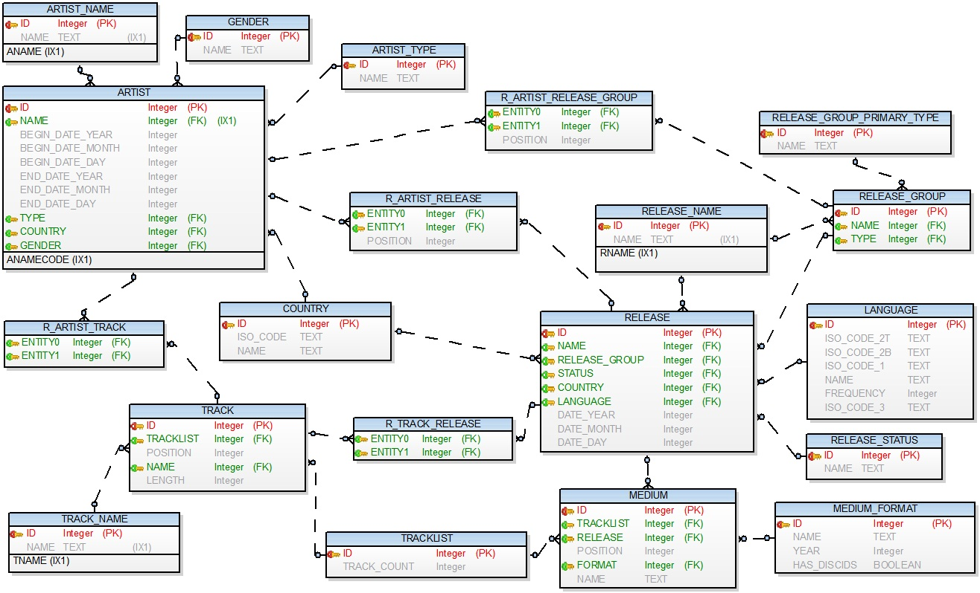

Determining the Number of Releases per Country

SELECT country.name AS "Country", COUNT(release.name) AS "Releases"
FROM country, release
WHERE country.id = release.country
GROUP BY country.name
ORDER BY "Releases" DESC;

United States 256477
United Kingdom 149674
Germany 93908
Japan 57338
France 42245
[Worldwide] 30920
Netherlands 19431
Australia 16549
Italy 16392
Canada 16376
Sweden 16316
Spain 14074
Finland 12733
Europe 10769
Russian Federation 10159
Brazil 8215
Belgium 8017
Poland 7088
Norway 4983
Denmark 4719
Greece 4174
Austria 4110
Argentina 3857
Switzerland 3737
Czech Republic 3252
Turkey 3149
New Zealand 2927
Estonia 2567
Hungary 2408
Taiwan 2362

Determining the Number of Releases per Country

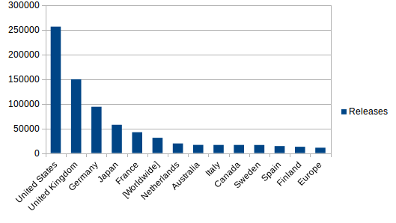

Some conclusions drawn from the above chart:

- The United States produces roughly as much music as the United Kingdom and Germany combined
- Both countries that lead in their number of releases both start with the word “United”

Determining the Average Track Count per Country

SELECT country.name AS "Country", AVG(tracklist.track_count) AS "Track Count"
FROM country, tracklist, release, medium
WHERE country.id = release.id AND release.id = medium.id AND medium.tracklist = tracklist.id
GROUP BY country.name
ORDER BY "Track Count" DESC;

New Zealand 38.0
Jordan 27.0
Soviet Union (historical, 1922-1991) 23.0
Mauritania 21.0
Nigeria 21.0
Norway 21.0
Niue 20.0
Georgia 19.0
Ghana 19.0
Madagascar 19.0
Switzerland 19.0
Algeria 18.0
Antarctica 18.0
Liberia 18.0
Mauritius 18.0
Swaziland 18.0
Zimbabwe 18.0
[Worldwide] 18.0
Hong Kong 17.0
Ireland 17.0
Togo 17.0
Yemen 17.0
Cuba 16.0
Honduras 16.0
Morocco 16.0
Palestinian Territory 16.0
Saint Helena, Ascension and Tristan da Cunha 16.0
Slovakia 16.0
South Georgia and the South Sandwich Islands 16.0
Tokelau 16.0

Determining the Average Track Count per Record
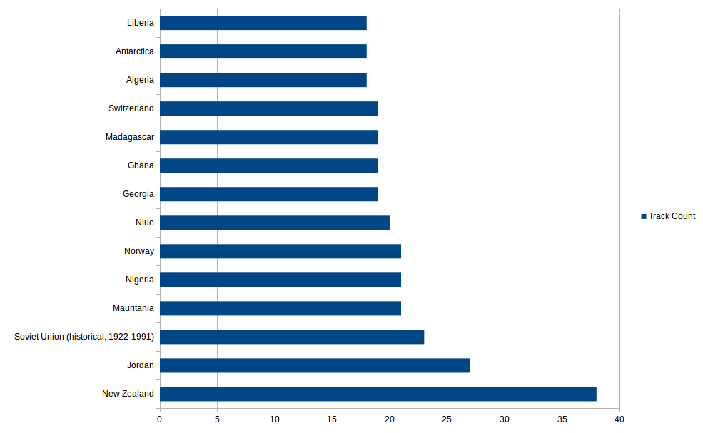
Some conclusions drawn from the above chart:

- Perhaps it is a cultural belief that New Zealanders should include a larger amount of tracks per record. Or perhaps America and Canada value music twice as much as New Zealanders do.

- The majority of the list is comprised of third-world countries.

Who Wrote the Longest Track?

SELECT artist_name.name, artist.country, track_name.name, MAX(track.length)
FROM artist_name, TRACK, track_name, r_artist_track, artist
WHERE artist_name.id = artist.id AND artist.name = r_artist_track.entity0 AND r_artist_track.entity1 = track.id AND track.id = track_name.id;

Riccardo Perotti Nouvelles suites de PiÃ¨ces de clavecin : Sarabande 10853000

The Amount of Releases per Media Format

SELECT medium_format.name AS "Format", medium_format.year, SUM(MEDIUM.FORMAT) AS "Count"
FROM medium_format, medium, release, release_name
WHERE RELEASE.ID = MEDIUM.RELEASE AND medium.format = medium_format.id AND release_name.id = release.name
GROUP BY medium.format
ORDER BY "Count" DESC;

12" Vinyl 2029136
Digital Media 939084
CD 1982 609873
7" Vinyl 523566
Vinyl 1895 296709
CD-R 115500
Cassette 1964 70920
8cm CD 1982 70550
10" Vinyl 55650
Wax Cylinder 1877 42938
DVD-Video 42598
HDCD 5875
Other 4602
SACD 1999 4002
DVD 1995 3806
Piano Roll 1883 2460
USB Flash Drive 2444
DVD-Audio 2052
VHS 1302
VCD 1232
DualDisc 2004 1060
Blu-ray 780

The Amount of Releases per Media Format

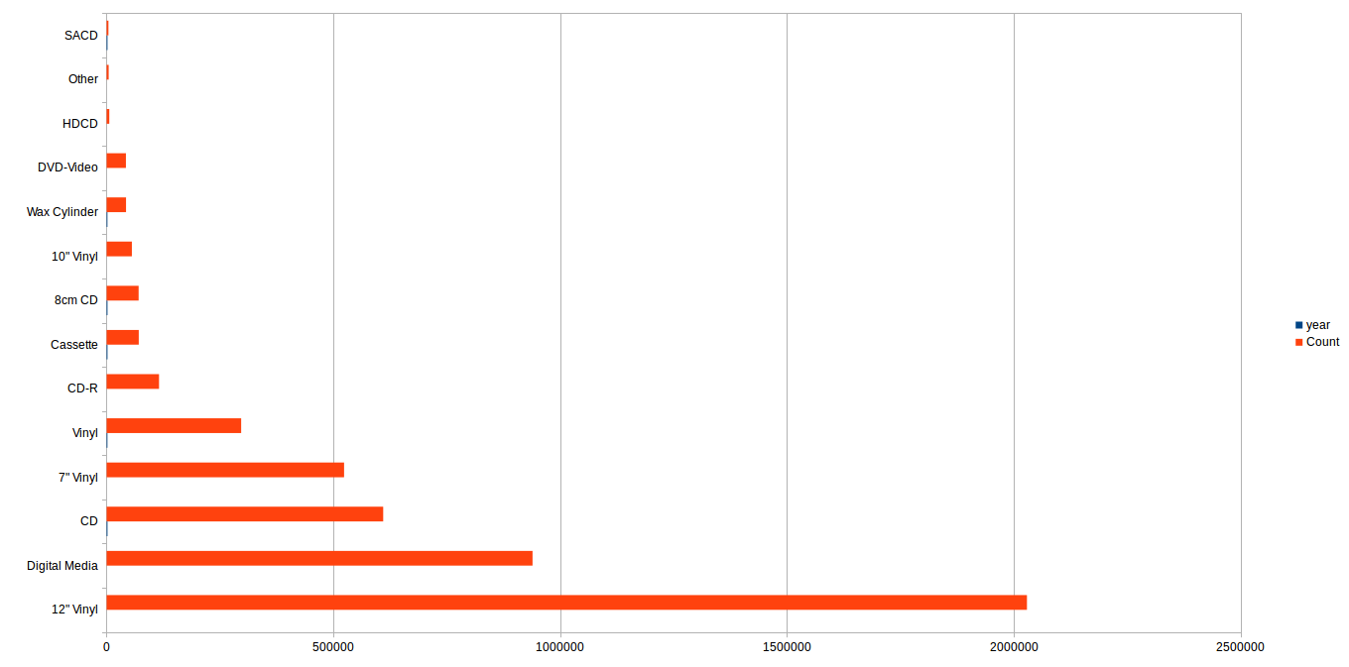

Some conclusions drawn from the above chart:

- Historically, releases have been on Vinyl, much more than any other media format.

- Digital Media needs more than 100,000 releases in order to overtake 12” Vinyl in quantity.

- The majority of media formats were niche products, or did not last long before the next-generation media format was released.

All Releases Including the Word ‘The’ in the Title

SELECT artist_name.name AS "Artist", release_name.name AS "Release", release.date_year AS "Year"
FROM r_artist_release, artist, release, release_name, artist_name
WHERE artist_name.id = artist.name AND artist.id = r_artist_release.entity0 AND r_artist_release.entity1 = release.id AND release.name = release_name.id AND release_name.name LIKE '%The%';

Love .45 The Seattle Sessions E.P.
raison d'Ãªtre Enthraled by the Wind of Lonelienes 1994
raison d'Ãªtre Reflections From the Time of Opening 1997
raison d'Ãªtre The Empty Hollow Unfolds 2000
raison d'Ãªtre Within the Depths of Silence and Phormations 1995
raison d'Ãªtre Reflections From the Time of Opening 2005
raison d'Ãªtre The Stains of the Embodied Sacrifice 2009
raison d'Ãªtre The Luminous Experience (Live in Enschede 2008) 2008
raison d'Ãªtre When the Earth Dissolves in Ashes (Live 2010/2011)2012
Rezerwat The Best of Rezerwat
Infester To the Depths, in Degradation 1994
Mhoo Talking in the Streets 2011
Mississippi Sheiks Honey Babe Let the Deal Go Down: The Best of Mississippi Sheiks 2004
Mississippi Sheiks Sitting on Top of the World / Lonely One in This Town 1930
Eberhard Weber The Following Morning 1976
Eberhard Weber The Colours of ChloÃ«
House of Low Culture Live From the House of Low Temperature! 2004
House of Low Culture Live From the House of Low Temperature! 2004
Choclair What It Takes - The Official Remixes (Placebo Recordings)
Stereobate Selling Out in the Silent Era
Flame The 6th 2012
Flame The 6th 2012
We Barbarians In the Doldrums 2008
Blake Together 2009
Greg Sczebel Love & the lack thereof 2009
...

What is the Shortest Track?
SELECT track_name.name, MIN(track."length")
FROM track, track_nam
WHERE track.name = track_name.id;

Sare 13

Which Bands Have Composed the Most Tracks?

SELECT artist_name.name, COUNT(track_name.name) AS "Count"
FROM artist_name, artist, r_artist_track, track, track_name
WHERE artist_name.id = artist.name AND artist.id = r_artist_track.entity0 AND r_artist_track.entity1 = track.id AND track.name = track_name.id
GROUP BY artist_name.name
ORDER BY Count DESC
LIMIT 100;

Johann Sebastian Bach 66924
[unknown] 62401
Wolfgang Amadeus Mozart 45717
Ludwig van Beethoven 34548
Georg Friedrich HÃ¤ndel 22576
Antonio Vivaldi 19918
J.K. Rowling 17649
U2 17441
Fryderyk Chopin 17125
Elvis Presley 15849
Joseph Haydn 14667
Grateful Dead 14279
The Beatles 14220
Johannes Brahms 14200
ÐŸÑ‘Ñ‚Ñ€ Ð˜Ð»ÑŒÐ¸Ñ‡ Ð§Ð°Ð¹ÐºÐ¾Ð²Ñ?ÐºÐ¸Ð¹ 14113

Which Releases Had the Most Tracks?

SELECT release_name.name, track_count
FROM release_name, release, medium, tracklist
WHERE release_name.id = release.name AND medium.release = release.id AND medium.tracklist = tracklist.id
ORDER BY track_count DESC
LIMIT 30;

Sony Sound Series: Loops & Samples: On the Jazz Tip 1008
Sonic Logos, Links and Beds 2 728
Sony Sound Series: Loops & Samples: Bass X 686
Fanfares 685
Ð—Ð°Ð±Ð»Ñ‘Ð²Ð°Ð½Ð½Ñ‹Ð¹ Ñ„ÑƒÐ¶ÐµÑ€ Ñ? Ð³Ð¾Ð²Ð½Ð¾Ð¼ 666
Comedy / Cartoon 644

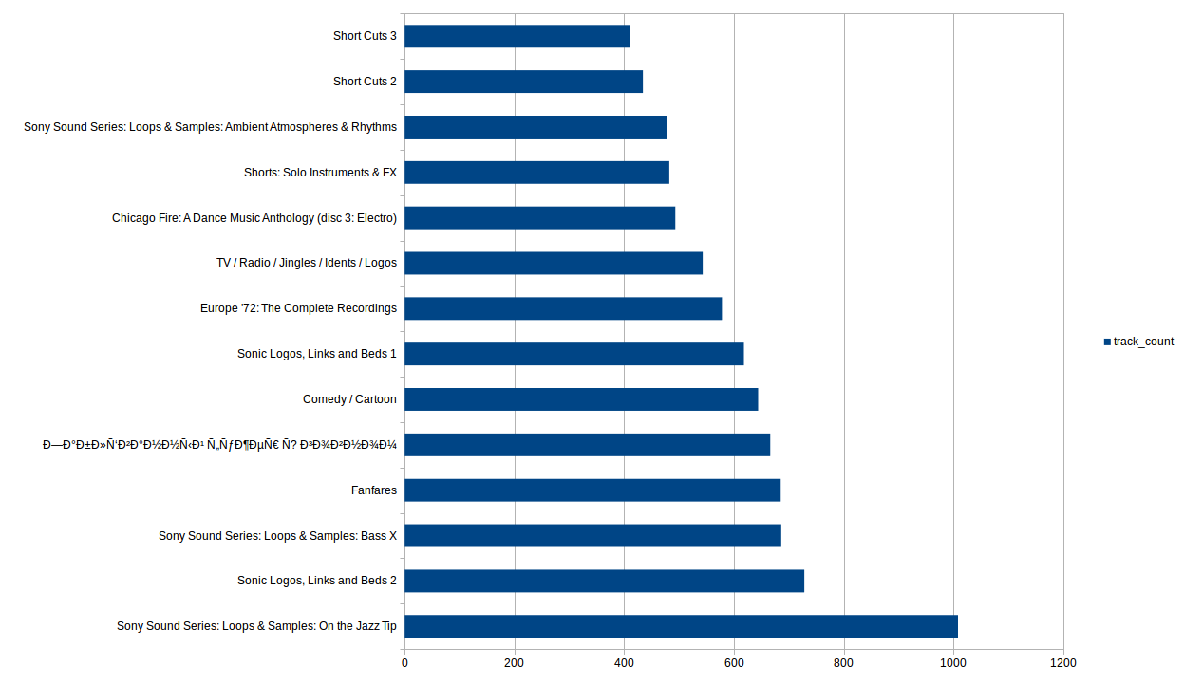

How Many Solo/Group Artists Exist per Country

SELECT t1."c1", "Person", "Group"
FROM
(SELECT country.name AS "c1", COUNT(artist_type.name) AS "Person"
FROM artist_type, artist, country
WHERE artist_type.id = artist.type AND artist.country = country.id AND artist_type.name = 'Person'
GROUP BY country.name) t1
JOIN
(SELECT country.name AS "c2", COUNT(artist_type.name) AS "Group"
FROM artist_type, artist, country
WHERE artist_type.id = artist.type AND artist.country = country.id AND artist_type.name = 'Group'
GROUP BY country.name) t2
ON t2."c2" = t1."c1"
GROUP BY t1."c1"
ORDER BY "Person" DESC, "Group" DESC;

United States 27265 16101
United Kingdom 12398 9772
Japan 7144 2318
Germany 6617 5168
France 5785 3765
Estonia 4133 1208
Spain 4058 1850
Italy 3594 2952
Finland 3550 2268
Greece 3038 605
Canada 2705 1973
Latvia 2570 489
Sweden 2108 2359
Netherlands 1977 1636
Australia 1581 1720
Turkey 1412 202
Poland 1222 1079
Russian Federation 1195 1059
Denmark 970 630
Brazil 932 582
Norway 855 906
Switzerland 792 500
New Zealand 770 829
India 758 64
Belgium 745 720
Austria 697 466
Jamaica 625 166
Ireland 577 334
Korea (South), Republic of 551 251
Czech Republic 474 399
How Many Solo/Group Artists Exist per Country

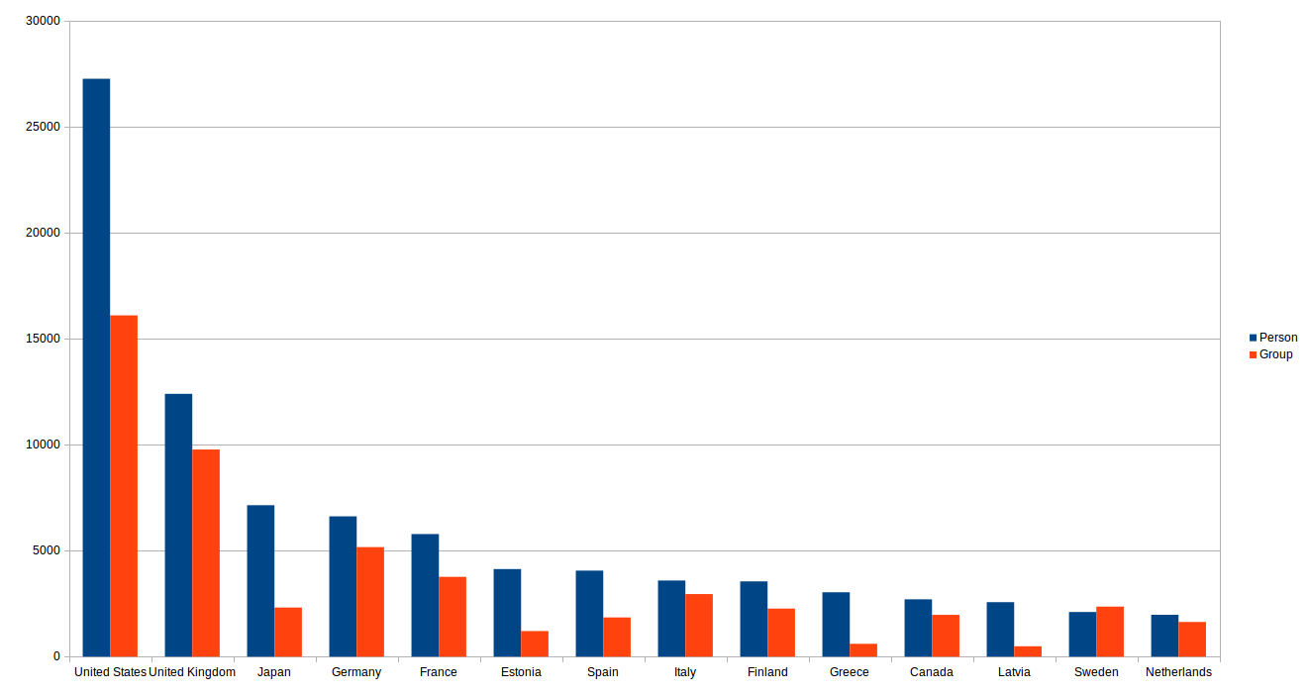
Some conclusions drawn from the above chart:

- Single-person artists are much more common than groups

- The only country to have more groups than individuals is Sweden

The Number of Men and Women Artists in Each Country

SELECT t1."c1" AS "Country", "Men", "Women"
FROM
(SELECT country.name AS "c1", COUNT(gender.name) AS "Men"
FROM gender, artist, country
WHERE gender.id = artist.gender AND artist.country = country.id AND gender.name = 'Male'
GROUP BY country.name) t1
JOIN
(SELECT country.name AS "c2", COUNT(gender.name) AS "Women"
FROM gender, artist, country
WHERE gender.id = artist.gender AND artist.country = country.id AND gender.name = 'Female'
GROUP BY country.name) t2
ON t2."c2" = t1."c1"
GROUP BY t1."c1"
ORDER BY "MEN" DESC, "WOMEN" DESC;

United States 16394 4425
United Kingdom 7126 1643
Germany 4310 824
France 4016 959
Japan 3271 2915
Spain 3156 395
Estonia 3029 1055
Finland 2462 824
Greece 2391 521
Italy 2333 500
Latvia 1908 654
Canada 1591 578
Sweden 1258 363
Netherlands 1080 277
Turkey 919 443
Poland 824 218
Australia 815 284
Russian Federation 811 149
Switzerland 576 113
Brazil 564 213
India 554 133
Denmark 542 171
Norway 485 139
Austria 458 90
Belgium 412 108
Jamaica 409 64
Argentina 356 53
New Zealand 322 150
Listing the Number of Men and Women Artists in Each Country

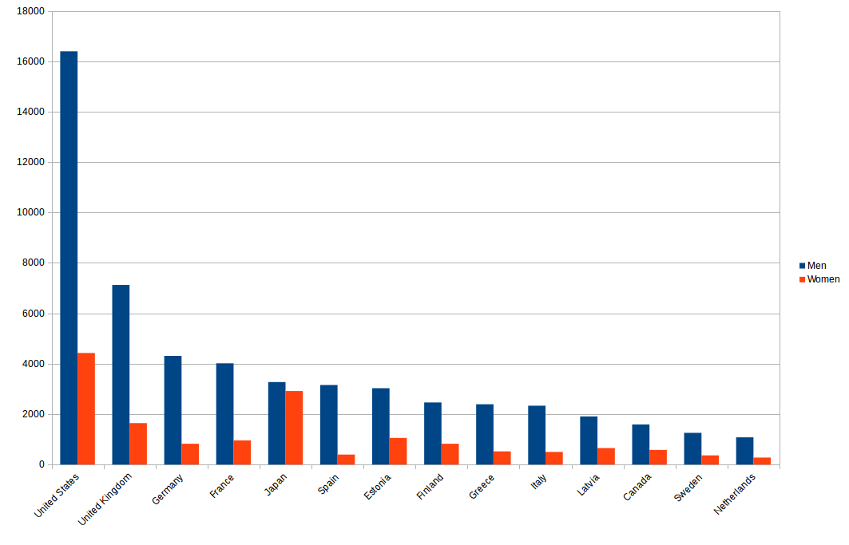
Some conclusions drawn from the above chart:

- Men release more music worldwide than women.

- The only country close to gender gap parity is Japan.

